|  |
| --- |
| **COSC2653 User-Centered Design** |
| COSC2653 - Assignment 1 11/01/2022 |
| Prepared by: Adam Mutimer (S3875753) https://github.com/AdamM-AU |
|  |

Contents

Part 1: Analysis of Application 3

**Introduction** 3

**Part 1.1: User Groups and Attributes** 4

**Group 1 – Citizens of Victoria** 4

**Group 2 – Interstate Workers** 4

**Group 3 – Interstate Travelers** 4

**Part 1.2: Main Tasks** 4

**Part 1.3: Analysis of Application** 6

Part 2: Survey and Report 8

**Part 2.1: Screener Question** 8

**Part 2.2: Survey Participants** 9

**Part 2.3 & 2.4: Survey Questions – Results Overview** 11

Conclusion: 15

References: 16

State Government of Victoria – **Service Victoria**

Figure 1

## Part 1: Analysis of Application

### **Introduction**

The purpose of this analysis is to analyze the useability of the “Service Victoria” application which is available for both iOS and Android operating systems.

The purpose of the application is to allow it’s intended audience a fast and simplistic way to access the most popular Victorian government transactions undertaken by Victorians and Visitors to the state of Victoria such as fishing licenses, vehicle or boat registration, authorized work permits and most commonly Coronavirus (COVID-19) check-ins and Vaccination certificates.

In this report we will be focusing on the most common transactions used on the “Service Victoria” application; Coronavirus (COVID-19) Check-ins and Adding a Coronavirus (COVID-19) Vaccination certificate, this was accomplished by allowing feedback on the current processes involved on our targeted transactions which was in the form of an online survey to a controlled group. Our expectation is that the “Service Victoria” application is easy to use for all ages to perform the two targeted functions and related functions.

### **Part 1.1: User Groups and Attributes**

Due to the nature of our chosen application; many of the attributes are common amongst our targeted user base, this also includes the various tasks in which we will be analyzing as we are more concerned about the usability of these tasks amongst the 3 targeted groups.

|  |  |  |  |
| --- | --- | --- | --- |
|  | **Group 1 – Citizens of Victoria** | **Group 2 – Interstate Workers** | **Group 3 – Interstate Travelers** |
| **Attributes** | * Lives in Victoria * Owns an android or apple device capable of installing the application * Uses the application * Basic to advanced application user * Aged 16+ | * Travels to Victoria regularly for work * Owns an android or apple device capable of installing the application * Basic user of the application * Aged 16+ | * Currently in Victoria or Planning to or has Travel to Victoria in the last 12 months * Owns an android or apple device capable of installing the application * Basic user of the application * Aged 16+ |
| **Tasks** | * COVID-19 Location Check-ins * COVID-19 Favorite Check-in Locations * COVID-19 Vaccination Certificate * COVID-19 Check-in History | | |

### **Part 1.2: Main Tasks**

“Service Victoria” is a Victorian Government application which is intended to streamline and simplify many of the most common government transactions performed by Victorian’s, Interstate Workers and Travelers to the state of Victoria.

The most common uses of this application are Coronavirus (COVID-19) related tasks such as COVID-19 Check-ins, COVID-19 Vaccination Certificates, COVID-19 Testing locations, etc. To assist the Victorian government in “Contact tracing outbreaks” as well as assist business with their COVID-19 Check-in register requirements.

The “Service Victoria” application also has several other features which are not the focus of this analysis such as vehicle or boat registration, fishing licenses, ambulance Victoria membership, working with children check, NDIS worker screening checks and more.

#### Coronavirus (COVID-19) – Check In

The “Check-in” task is intended to make it faster and easier to check-in to locations that the user is visiting or working at and to assist business with keeping an accurate COVID-19 visitor register by using an online mobile solution as opposed to the alternative method requiring visitors to write down their details into a logbook that the company needs to maintain as required in the state of Victoria.

The check-in process can also display the visitors or workers COVID-19 vaccination status and certificate for businesses that can only grant entry to those with valid certificates and current vaccination status’ again avoiding the need for visitors to carry paperwork in relation to their vaccination status and streamlining the record keeping for businesses.

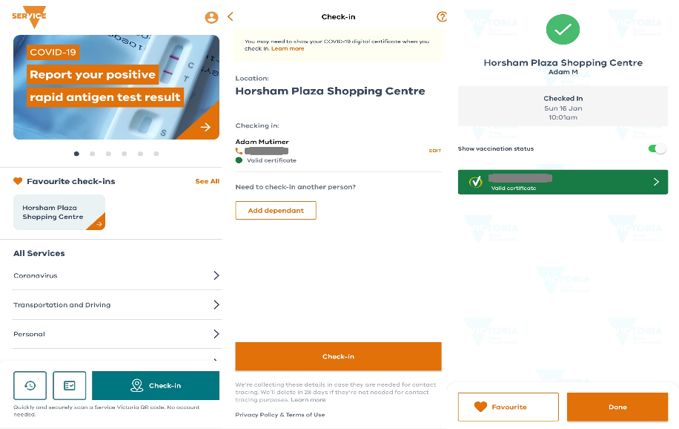

Figure 2 – Check-in process screenshots

#### Coronavirus (COVID-19) – Vaccination Certificate

The process of adding a COVID-19 certificate to “Service Victoria” is somewhat a hindrance with this application as it requires the user to have both a “MyGov” account, which is a Federal Government initiative to combine all federal government online services into a single website. The user is also required to have their Medicare online account linked to “MyGov” OR have the “Express Plus Medicare” Application installed on their device with a valid Medicare online account.

The easiest of the two methods is to install the “Express Plus Medicare” Application and share the certificate with the “Service Victoria” application. “Service Victoria” has released instructional videos to explain to the userbase how to accomplish this task using the two methods.

They are available here:  
Medicare Application:  
<https://service.vic.gov.au/covid-19/add-covid-19-digital-certificate#add-covid-19-digital-certificate-medicare-app>

MyGov:  
<https://service.vic.gov.au/covid-19/add-covid-19-digital-certificate#add-covid-19-digital-certificate-mygov>

#### Coronavirus (COVID-19) – Check in history

Check-in history is a record of the applications last 28 days of check-in locations performed by the user, and is a very simplistic task for the user, which includes the location name, date, and time of the check-in for the user to refer should they need to, it also includes a search function intended for high volume check-in users to assist them to find the check-in information that they require.

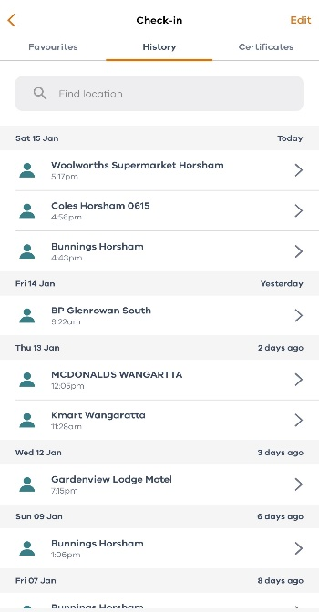

Figure 3 - Check-in History

#### Coronavirus (COVID-19) – Check-in favorites

The “Check-in favorites feature is intended to speed up the ability for users of the application to “Check-in” to commonly visited locations and businesses by bypassing the requirement for the user to scan the QR code each time they visit the location or business. The user is given the option to add the location to their “Favorites” upon the first QR code scan for the location or business.

After which the user simply needs to only select the location on the menu thereafter to check-in to the location rather than queue behind other users or look around for the QR code to scan it.

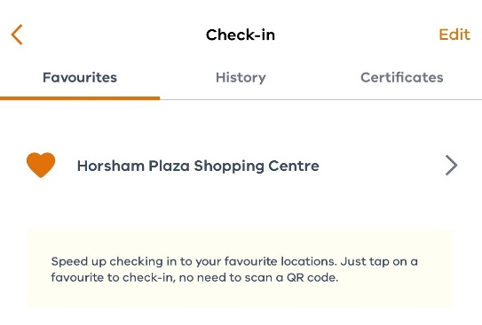

Figure 4 - Check-in Favorites

### **Part 1.3: Analysis of Application**

As a citizen of the state of Victoria, I am a user of the “Service Victoria” application for both work and personal purposes mainly the Coronavirus (COVID-19) related tasks. The following analysis draws from both my own experiences with the application and information gathered from the online survey. The results from the online survey will also be used as evidence to support any and all conclusions made in this analysis of the “Service Victoria” application.

To accomplish this, we will be measuring the applications usability in the targeted processes against “Krug’s 3 Laws of usability” to determine which area, if any, need improvement, although considering the Victorian Government has considerable resources at their disposal not many areas of the application may require usability improvements, but also taking into consideration, the speed in which this application was deployed to the public their still may be areas requiring usability improvement.

#### Krug’s First Law: “Don’t make me think”

Using the information from the survey, The participants have indicated that the application is quite easy to use overall, which I would have to agree too, however when asked about our targeted processes in the application, participants only had very mixed results in relation to “Adding a Certificate”, from my own personal experience this can be a quite difficult process to accomplish when adding a certificate for the first time, based on the mixed results given by the users surveyed, this process will need to be investigated further in relation to its useability.

The process of “Adding a certificate” relys on external sources, each requireing their own login credentials that the user is expect to know and/or obtain before attempting this process. Which in my opinion requires the user to think and makes the process more complicated to navigate for the users of the application.

|  |  |
| --- | --- |
| Graphical user interface, text, application  Description automatically generated  Figure 5 - Add COVID-19 Digital Certificate | Figure 6 - Digital Certificate |

#### Krug’s Second Law: “It doesn’t matter how many times I have to click, as long as each click is mindless, unambiguous choice” or “Users like mindless choices”

Our target processes of this analysis require very little interaction from the user and are generally unambiguous choices. However, I do not believe based on the results of the survey or my own experiences that the process of adding a “Certificate” to the application meets this criterion, the process relies on external applications which complicate the process and at times are not clear, they also require additional log-in information which further complicates the process if the user has not got these details.

#### Krug’s Third Law: “Get rid of half the words on each page, then get rid of half of what is left.” Or “Omit needless words”

All aspects of the application including the targeted processes have very little onscreen text and information to avoid overwhelming the user, only the essentials unless the user requires more information, and the user selects this option. Leaving the interface clean, simple, and easy to navigate.

## Part 2: Survey and Report

This survey report is based on the contents of a survey conducted for existing or recent users of the “Service Victoria” application targeting the “Coronavirus (COVID-19)” functionality of the application in relation to its usability.

The survey is located at the following URL:  
<https://forms.gle/TgWcWcigaLFrn1yHA>

The results of the survey have been exported into a spreadsheet which is available on the following URL:  
<https://drive.google.com/file/d/1HvzMLssse7Zs1XFzaZo9iu-k4GHiHyXV/view?usp=sharing>

All data in relation to this survey are also located on the following GitHub repository:  
<https://github.com/AdamM-AU/COSC2653_A1/tree/master/Survey%20Data>

This survey was conducted to gauge user feedback on a targeted group of processes to determine their ease of use. These targeted tasks are the most performed tasks undertaken by the “Service Victoria” application and are used by citizens of Victoria, interstate workers and interstate travelers whilst in the state of Victoria.

Even though it’s not required; The survey takes into account both the age group and device used by the user, I deemed this information necessary so that we can determine if the useability affects a certain age bracket more than others, as well as if the issue is more prone to occur with a certain device.

The results for all questions will provide an indication on what particulars of the “Service Victoria” application need to be addressed or the application in its entirety. As forementioned this survey is only focusing on the most performed tasks/processes, also referred to in this report as our targeted processes” which are Coronavirus (COVID-19) related processes, which include:

* Coronavirus (COVID 19) – Check-in
* Coronavirus (COVID 19) – Vaccination Certificate
* Coronavirus (COVID 19) – Check-in History
* Coronavirus (COVID 19) – Check-in favorites

The “Service Victoria” application has many other features as previously mentioned, but they are not covered by this report or survey.

### **Part 2.1: Screener Question**

The screener question is the first question presented to the participant, requiring the participant to answer a simple yes or no question, to determine if they are a member of one or more of our three groups, only if the participant if a member of one or more of our user groups could they continue to answer questions in our survey.

#### Have you or have you ever been a user of "Service Victoria" YES/NO

Even though this survey was only given to people that fit in one or more of our three groups, we did receive two responses of “no”, but received fifteen responses of “yes”. The responses of “no” could have been due to various reasons but are not our concern for the purpose of this report and will be disregarded.

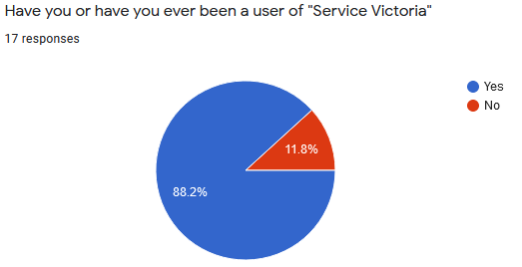

### **Part 2.2: Survey Participants**

Not including the screener question, the first five questions asked in the survey were strategically chosen to help us group our participants and gain more insight into the userbase to assist in identifying the usability issues with greater detail, such as allowing the identification of issues that generally affect a certain age group or device and if they are heavy, moderate, or low use user of the application, etc. using this information in combination will assist in weighting the results in order of relevance.

#### Q2) What is the primary reason you use the “Service Victoria” application?

The majority (60% [9]) of users use the application for both personal and work, 26.7% [4] of users only use the application for personal use, whilst 13.3% [2] of users use the application for work purposes only.

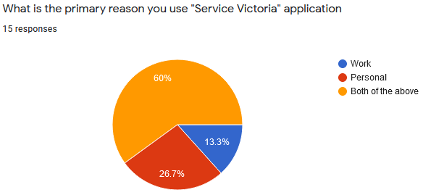

#### Q3) please enter your age?

Most of our survey participants are in the 31 – 40-year age bracket, however we did reach some participants in other age brackets except for 41 – 50 and a single participant who chose not to reveal their age. This information can be used to determine what age groups reported issues and what groups did not. Based on age we are also able to assume the level of competency of users performing tasks on their smart phone devices.

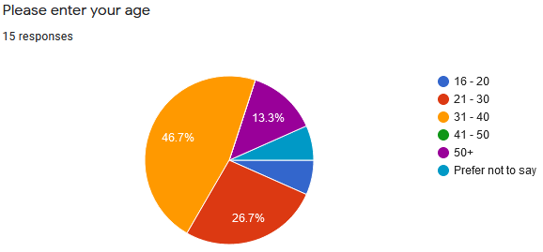

#### Q4) How long have you used “Service Victoria”?

This question revealed to us that only 53.3% of our surveyed users have been using the application for more than 12months and that 26.7% have been using the application for less than 6 months, and only 20% of users have been using the application for 12months.

From this information we can safely assume that most users have been using the application for at least 12months (73.3%) and have intimate knowledge of the features and processes offered by the application that we are targeting.

#### Q5) What kind of mobile device do you have?

This question is here to help identify if a particular type of device has a UX/UI issue, it can also be used to assist in telling us the level of competency a user has in relation to their smart phone device if they can identify the OS the phone is running. A staggering 93.3% of surveyed participants were able to identify their device group, while only a single participant was unable.

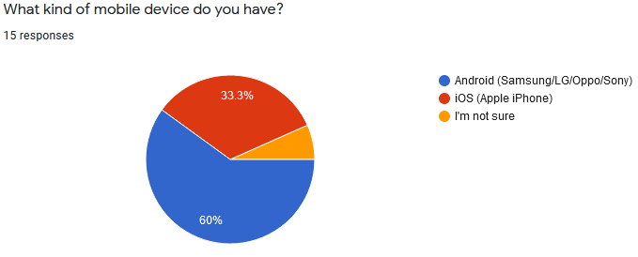

#### Q6) How often per day would you use “Service Victoria” on average?

53.3% of our surveyed users on average use the application almost once per day on average, whilst 33.3% reported they use the application 2 – 3 times per day, 6.7% use the application 4 - 6 times per day and another 6.7% of use the application 7+ times per day.

This data informs us that 53.3% can be considered low application users, 39.7% of users can be consider medium application users and 6.7% can be considered heavy application users.

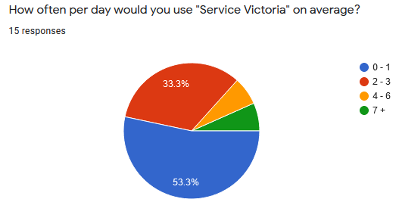

### **Part 2.3 & 2.4: Survey Questions – Results Overview**

As previously mentioned in section “Part 2.2: Survey Participants” five questions not including the screener were placed at the beginning of the survey to assist in breaking down the participants into groups to assist in grouping their responses, this section will focus on questions in relation to the usability of our targeted processes.

**Questions 7 – 12 – Application Design**

#### Q7) When you first installed and used “Service Victoria” how difficult did you find it to use?

Question was ranked 1 (Very Difficult) – 10 (Very Easy) this question is intended to give us a base line on how the participant feels about the application overall, for example results which do not match the consensus of the participants should be ignored for example if only 1 of 20 participants gave us a score of 1 it should be ignored.

On average all our participants scored this 6+ with the bulk giving us a score of 10, indicating we possibly have good participants. This question alone by no means indicates the participant is happy with the useability of all aspects of the application as the participant has not yet been required to think about any single process in the application.

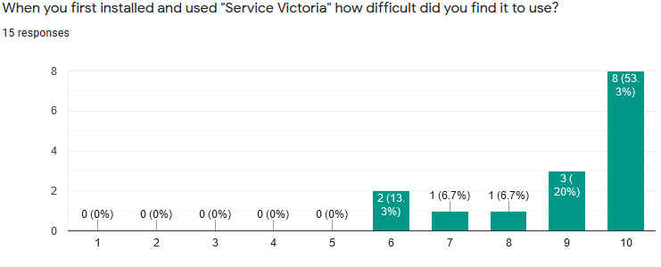

#### Q8) After using “Service Victoria” for some time, how would you rate its usability now?

Question was ranked 1 (Very Difficult) – 10 (Very Easy). This question is like the previous question but asking the participant about their experiences with the application after using it for some time. If a participant was to give us a lower score here versus the previous question this would indicate an issue with changes that have been made to the application, if a participant gives us a higher score compared to the previous question, we know the applications usability is improving.

This question can also assist us to weight biased responses from users who dislike the application for various reasons.

Based on the results of this survey question we have a very close match in responses between this question and the previous question, therefore we could safely consider that the survey participants like the applications overall useability for processes they use routinely, but again the participants have not been asked to think about any single process in the application.

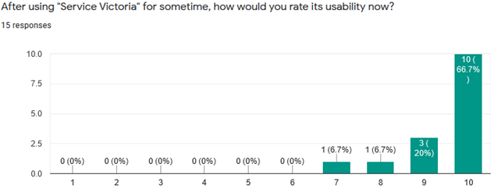

#### Q9) How would you rate the “Check-in” process?

This question is targeting the usability of the “Check-in” process of the application and was placed on a scale of 1 (Difficult) – 5 (Easy). From reviewing the results 66.7% of participants found this easy with a score of 5 whilst 26.6% scored it 3 – 4 implying it’s got an average difficulty rating, 1 participant gave the application a score of 1 which we can safely ignore due to it not matching the overall results, looking further into the participants survey results this may have simply been an error on the participants behalf.

#### Q10) How would you rate the “Adding a Certificate” process? This question is targeting the usability of the “Adding a Certificate process of the application and was placed on a scale of 1 (Difficult) – 5 (Easy); The results of this question were indecisive with scores up and down the scale. This would indicate a possible issue with the process and should be reviewed in more detail.

#### Q11) How would you rate the “Adding a Favorite” check-in process?

Scaled question of 1 (Difficult) – 5 (Easy); 80% of survey participants gave this a score of 4 or higher, while only 20% gave it a score between 2 and 3. It can be assumed that the usability of this process is more than acceptable.

#### Q12) How would you rate the “Check-in History” process?

Scaled question of 1 (Difficult) – 5 (Easy); Overall 73.3% of participants scored this process a 5, 20% of participants scored this process a 4. Only 6.7% [1] gave us a score of 2, which can be ignored as it doesn’t fit the participants consensus.

We can safely assume that users are satisfied with the usability of this process, but there is still room for improvement.

Question 13 & 14 – Features and Changes

#### Q13) What is your opinion on the features included in “Service Victoria” application?

This question was added in addition to the other questions to determine if the UI/UX was too complex, requiring users to think to navigate to the tasks they wished to perform.

Based on participant responses only a single participant believed there was too many features included whilst 40% believed it had an average amount of features and 53.3% had no opinion on the matter.

#### Q14) Has there ever been an incident, that due to a change it was difficult to use the application or were unable to use the application?

This question was added to the survey to determine if users recall and time that an update to the application made it difficult to use the application or the application become unusable. The participants were only able to select from 3 responses.

66.7% [10] of participants experienced no such incident and a further 26.7% [4] were unsure if they did or not and only 6.6% [1] had such an incident. Participants who selected Yes or unsure as their response were given access to an additional question (Question 15)

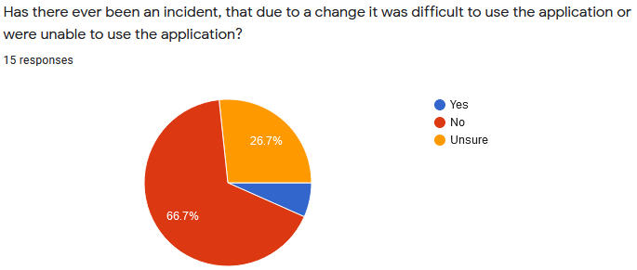

#### Q15) Conditional Question (Question 14 condition) - Could you provide details on the incident, that due to a change it was difficult to use the application or were unable to use the application?

This conditional optional question was added to give us some insight into the incident that affected the participant to check its relevance to the report, not to be used as evidence to confirm that an issue exists without other evidence from previous questions. Of the 33.3% of user who responded with either a Yes or Unsure to question 14 only two participants supplied information about the incident.

|  |
| --- |
| Had difficulty adding a certificate, help pages didn't really help at all and I found they were not very clear |
| Couldn't find my vaccine certificate |

Together these to responses would indicate issues with the “Adding a certificate” process however not directly being the UI/UX or a usability issue

#### Q15) Final Thoughts - Any further comments regarding the application or the survey can be added below thank you again.

This optional question was given to the user to allow them to leave any comments about the survey or application and has no real bearing on this report whatsoever besides giving the user a voice to feel like they actively participating in design of the application.

|  |
| --- |
| Application is very slow |
| No |
| Easy app to navigate, very easy to update information and add additional people if needed. |

## Conclusion:

Taking in to account the raw information from the survey and appropriately weighting the participants responses we can safely assume that we reached our 3 targeted groups, Citizens of Victoria, Interstate workers, Interstate Travelers.

We can determine this based on the responses given from questions 1,2 and 3 should also be taken into consideration. Based of this information we can assume that 13.3% of participants are Interstate workers only using the application for work purposes, we can also assume that 26.7% are interstate travelers as they are only using the application for personal use. Whilst the remaining 60% are most likely citizens of the state of Victoria. There could also be a grey area with the 60% being interstate workers whilst also being interstate travelers.

From the remaining questions targeting the applications useability, as we expected with a government application our participants of the survey were quite pleased with the application and overall found it quite easy to use.

However, after asking the participants to think about their experiences with particular processes within the application. We were able to identify that “Favorite Check-in Locations” has room for usability improvement even though its only slight.

We were able to successfully identify that the usability of the process of “Adding a certificate” needs to be investigated further as we received mixed results on a scaled question from our participants in relation to this task, some users indicated having difficulty whilst others had no issues at all. Further inspection on the results indicates no similarity between the participants details, such as age group, device, reason they are using the application, or how long they have been using the application.

## References:

* **Figure 1 – [Online] Available at:** [https://play.google.com/store/apps/details?id=au.gov.vic.service.digitalwallet.citizen&hl=en_AU&gl=US](https://play.google.com/store/apps/details?id=au.gov.vic.service.digitalwallet.citizen&hl=en_AU&gl=US%20) **[Accessed: 05/01/2022]**
* **Rastplatznotizen. - Krug’s 3 laws of Usability – [Online] Available at:** [https://twobenches.wordpress.com/2008/06/05/krugs-3-laws-of-usability/](https://twobenches.wordpress.com/2008/06/05/krugs-3-laws-of-usability/%20) **[Accessed: 05/01/2022]**
* **Figure 5 -** *Add COVID-19 Digital Certificate* **[Online] Available at**[**:** https://service.vic.gov.au/covid-19/add-covid-19-digital-certificate](:%20https:/service.vic.gov.au/covid-19/add-covid-19-digital-certificate) **[Accessed:06/01/2022]**
* **Figure 2,3,4,6 – Screenshots by Adam Mutimer.** Android “Service Victoria” Application, **Available at:** <https://github.com/AdamM-AU/COSC2653_A1/tree/master/Application-Images> **[Created: 15/01/2022]**